Visual thinking is a proces that has the allocation of attention as its very essence. We allocate scarce “working memory” resources to briefly retain in focal attention only to those pieces of information most ikely to be useful. It is more accurate to say that we are conscious of the field of information wo which we have rapid acces rather then that we are immediately conscious of the world.  
**Visual thinking consists of a series of acts of attention, driving eye movements and tuning our pattern-finding ciruits.** These acts are called **visual queries**.

Broadly speaking, the act of perception is determined by two kinds of processes: **bottom-up**, driven by the visual information in the pattern of light falling on the retina, and **top-down**, driven by the demands of attention, which in turn are determined by the needs of the tasks.

In the **Bottum-up** view, information is successfully selected and filtered so that meaningless low-level features in the first stage form into patterns in the second stage, and meaningful objects in the third stage.The main *feature processing stage* occurs after information arrives in the V1 cortex, having travelled up the optic nerve.

At the intermediate level of the visual processing hierarchy, feature information is used to construct increasingly complex *patterns*. Visual space is divided up into regions of common texture and colour. Long chains of features become connected to form continuous contours. Understanding how this occurs is critical for design because at the level at which space becomes organized and different elements become linked or segregated.  
At the top level of the hierarchy, information that has been processed from millions upon millions of simple features has been reduced and distilled through the pattern-processing stage to a small number of *visual objects*. The system that holds about three objects in attention at one time is called *visual working memory*. Because we can only store little information in this visual working memory, we must rely on external visuals to aid us in the process of visual thinking.

The real power of visual thinking rests in pattern finding. Often to see a pattern is to find a solution to a problem. Responses to visual patterns can be thought of as another type of pattern.

Retinal image -> features -> patterns -> objects

Next to **Bottum-up** vision, there is **Top-down** vision. We use the word *attention* to describe top-down processes. Top-down processes are driven by the need to accomplish some goal. This might be an action, a cognitive goal or something else. There is a constant lining and re-linking of different visual information with different kinds of nonvisual information. There is also a constant *priming* of action plans and plans being executed. This linking and re-linking is the essence of high-level attention, but it also has implications for other lower-level processes.

At te low level of feature and elementary pattern analysis, top-down attention causes a bias in favour of the signals we are looking for. If we are looking for red spots than the red spot detectors will signal louder. What we end up actually perceiving is the result of information about the world strongly biased according to what we are attempting to accomplish.

## Implications for Design

If we understand the world through just-in-time visuals queries, the goal of information design must be to design so *that visual queries are processed both rapidly and correct for every important cognitive task the display is intended to support.* This has a number of important ramifications for graphic design. The first is that in order to do successful design, we must understand the cognitive tasks and visual queries a graphic is intended to support.

A useful way of describing the way the brain operates to solve problems is as a set of nested loops. Outer loops deal with generalities. Inner loops process the details. In the outer loop, the brain constructs a set of steps to solve the problem and then executes them.

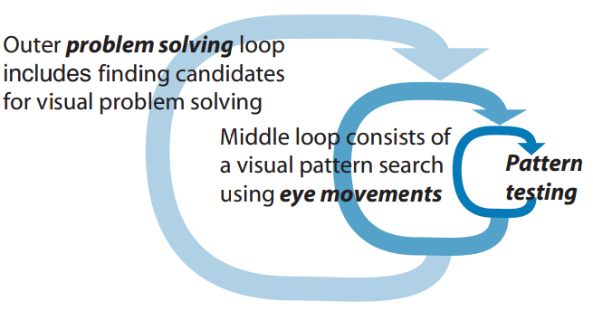

The middle loop on the diagram is a visual search executed to find patterns that addres the visual query. This involves executing a sequence of eye movements. The inner loop is activated when the eye arrives at the point of fixation. A process of visual testing begins.